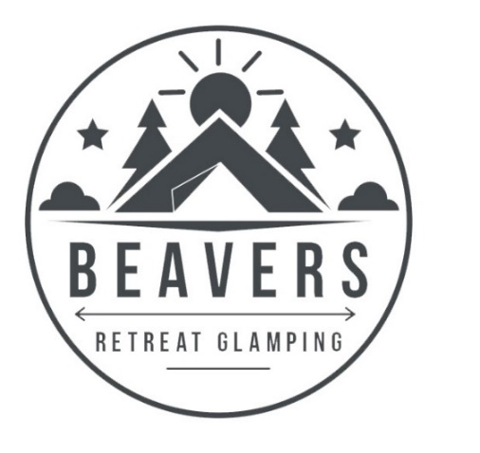

What to Bring and What we Provide
We have tried to think of everything within reason to make your stay at Beavers Retreat as comfortable as possible.
You should only have to bring clothes, food, toiletries, swim suits, suntan lotion, towels (bell tents only), rain coats and wellies.
For sleeping we have provided 13.5 tog duvets for the beds, bed linen & blankets should you need them.
For washing we provide shampoo, conditioner and body wash in the communal showers for all guests to use. Geodome guests have towels provided, whereas bell tent & luna tent guests will need to bring towels with them.
In the Toilets we you will find loo paper, hand towel and hand soap.
For cooking each Tent or Geodome has its own sheltered kitchen area stocked with pots, pans, crockery, cutlery, cooking utensils, BBQ utensils and essential condiments. The Geodomes have a full gas oven, 4 hobs and a grill. The Luna tents and the Bell tents have a double gas camping stove and grill.
For Refrigeration we recommend bringing a cool box along with you. We can then refreeze ice blocks upon request, or the local shop just up the road sells bags of ice. We do not provide a cool box.
For woodburning stoves & hot tubs, (Geodome) we provide fire-lighters, kindling and firewood. We provide plenty for your first night, and there is more available on site to purchase at a small cost if needed.
For hot drinks each kitchen area is stocked up with sachets of coffee, tea, hot chocolate and sugar. There is a double gas stove to boil the water in the kettle that is provided.
For Lighting there is LED battery lanterns provided in each unit.
For barbecuing we provide a BBQ, fire pit, and BBQ utensils. We do not supply charcoal for the BBQ.
For the fire pits firewood, kindling and firelighters can be bought on site, although you are welcome to bring your own with you.

We hope that this answer some of the questions you may have had, but if you have any further questions please do not hesitate to contact us.

