Beavers Retreat Glamping

Luxurious Glamping & Yoga Retreat

19th-21st June 2020

New for 2020, Beavers Retreat Glamping have teamed up with the experienced yoga teacher; Kerry Morgan, and will be delivering a luxurious weekend of Yoga, health & well-being and massage.




The Nitty Gritty
- You will be able to check in any time from 1pm on the 19th of June. Kerry will introduce herself and the group meet & greet will commence at 5pm. The full schedule will be explained, and any questions will be answered.
- All food, snacks and non-alcoholic drinks are included. This will consist of 1 evening meal on the Friday; breakfast, lunch and evening meal on the Saturday; and breakfast on the Sunday before check out at 12pm.
- Kerry will be hosting the weekend and will be running all of the yoga sessions.
- 1 x 30-minute massage is also inclusive, and these will be available on site on Saturday 20th June.
- Our Glamping site has a total of 10 units (7 bell tents & 3 Geodomes with hot tubs). For this retreat, we are selling 2 places per unit, thus a total of 20 people.

Pricing
- Bell Tent accommodation (2 sharing) - £400pp.
- Geodome with hot tub accommodation (2 sharing) - £500pp.
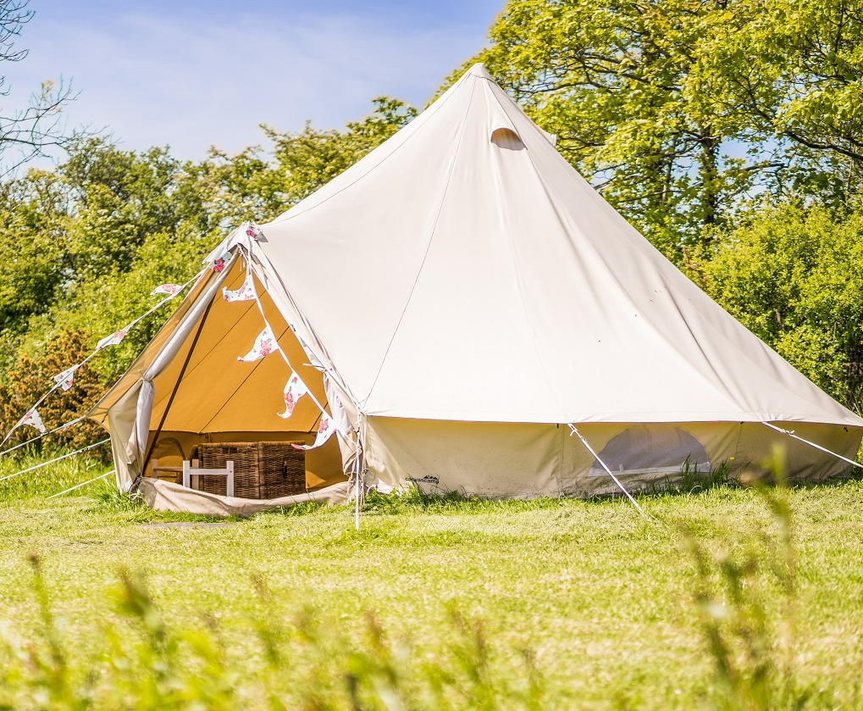
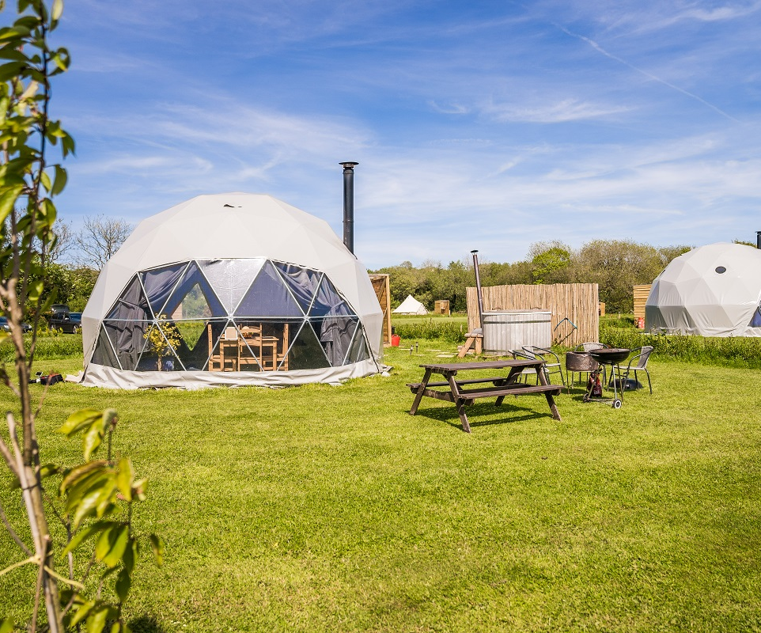

Why come on this Yoga Retreat?
Making time in your busy and stressful life to come on retreat with us is one of the best gifts you can give to yourself. If you spend your days running from one thing to the next then this retreat can be the perfect opportunity for you to restore and rejuvenate your mind, body and soul.
This retreat is all about you, your yoga, eating healthy, beautifully prepared, nutritious food and completely loosing yourself in our tranquil surroundings.

Booking on this retreat is a great investment and here are just a few reasons why…
- We have an abundance of energy and love what we do.
- You can expect well thought out vegetarian meals that are not only nutritious but also delicious.
- You will receive tuition from an experienced yoga teacher, who guides students of all levels though the fundamental steps of yoga practice.
- We are based in a beautiful and remote part of Pembrokeshire, allowing you the opportunity for some time offline without any distractions.
- You can completely relax in a peaceful atmosphere that will no doubt reduce your stress levels.
- Relax in the wood fired hot tub, perfect during the day between classes or in the evening when the stars are out.
- Whether you are going by yourself, with a friend, or with your family, being surrounded by other like-minded people is sure to invigorate you.

So whether you’re new to yoga, or you´d like to deepen your practice, our yoga retreat is a real treat – time to relax and restore and return home to everyday life with a renewed sense of energy, optimism and wellbeing.

FOOD MENU

Day 1
Main Course
Homemade Vegetarian lasagne served with garlic bread, green salad
& Coleslaw
Dessert
Oat & apple Crumble or fresh fruit salad
A small cheeseboard

Day 2
Breakfast
Porridge, Granola, Fresh yogurt & fresh fruit
fresh breads & Croissants.
Fruit juice, tea & coffee
Lunch
Red pepper & Feta frittata served with a selection of salads
Evening meal
Vegetarian chilli & Rice served with a mixed pepper salad, guacamole & sour cream.
Dessert
Homemade salted caramel chocolate torte or fresh fruit salad
A small cheeseboard

Day 3
Breakfast
Porridge, Granola, Fresh yogurt & fresh fruit
fresh breads & Croissants.
Fruit juice, tea & coffee


WEEKEND PROGRAMME

Friday

1.30pm -3.30pm Arrival
4.30pm Welcome & introductions
5.30pm Evening meal
7.30pm Mellow restorative practice & yoga nidra
9pm Chill out time



8am Energizing morning flow & meditation
9.30am Healthy delicious breakfast
11am The science of happiness (talk) followed by mindful movement
1pm Healthy nutritious veggie lunch
2-6pm Massage & free time to read, relax & enjoy the beautiful surroundings
5.30pm Delicious Veggie feast
7.30pm Grounding flow and yoga nidra
8.30pm Sunset view point
OR HIIT

8am Rise & shine morning flow & meditation
9am Breakfast
10-11.30am Massage & free time to read, relax & enjoy the beautiful surroundings
11.30 Closing ceremony & bon voyage - we hope to see you again
12.30 Departure

Sunday
Saturday

